BUSINESS: Read and Watch It!
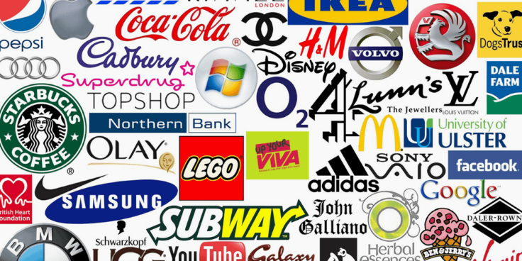
The business world has to be a proactive and reactive place, therefore trying to predict changes. As well as reacting to those external factors that a business will be impacted by.
Proactive changes could be internal, such as a change in staffing structure and opportunities to expand brand and products. More reactive changes tend to be from external factors. These are harder to predict and until they happen fully understand how they could impact your business activity.
During the course we will continually be asking you to bring in ‘outside’ learning. What are businesses doing? How do they hire staff? What is their promotional activity? What is the impact to the business of external factors?
What is happening in the real work of business?
Therefore, below are some essential reading / watching to get thinking about business. Remember there are businesses all around you. Big and Small, independent and multinational. Yes, they are trying to be successful, grow and make profit. But their purpose and objectives vary.
Watch It:
TASKS / QUESTIONS / CONSIDERATIONS

How will restaurants price their products after lockdown? Will they give special offers to bring you in, OR can they charge more on their menus because people will be so keen to socialize?

How do independent business recover from COVID-19? How would you suggest they increase their revenue once lockdown is over to recover their losses?

Which businesses have benefited from the lockdown and why?

Do you think the lockdown has encouraged people to start their own business ventures and why?

Movies
The Pursuit of Happyness
The Big Short (Cert: 15 - Available on Netflix)
Fyre (Available on Netflix)
The Founder – The Story of Ray Kroc (McDonalds) (Amazon Prime)
TV – On demand/Catch Up
Tricky Business (Channel 4)
Dragons Den (BBC)
Pepsi VS Coke – A Marketing Battle (Amazon Prime)
Undercover Boss
Inside Sainsburys
Amazon: What they know about us (BBC)
Broken: An episode of Ikea (Netflix)
Rotten (Netflix)
The Real Chocolate Factory (Channel 5)
Websites:
www.bbc.co.uk/news
www.bbc.co.uk/business
www.tutor2u.co.uk
www.bized.ac.uk
http://businesscasestudies.co.uk/#axzz35SdxMLJP
http://www.businessdictionary.com/
www.beebusinessbee.co.uk
Youtube:
Bee Business Bee
Two Teachers

